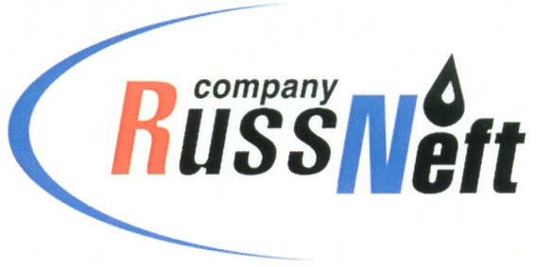
PJSC “RUSSNEFT” PRESS SERVICE

Tel.: (495) 411-63-24; (495) 411-63-21  Fax: (495) 411-63-19  E-mail: pr@russneft.ru  www.russneft.ru | 115054, Moscow,  Pyatnitskaya str., 69

PRESS RELEASE
May 17, 2019

The annual meeting of shareholders of PJSC “RussNeft” will be held on June 21 in Moscow

The Board of Directors of PJSC “RussNeft” decided to hold the Annual General Meeting of Shareholders of the Company on June 21, 2019 in Moscow and approved its agenda.

Based on the production and financial results of RussNeft in 2018, the Board of Directors proposed to pay dividends on preferred shares in the amount of $40 million.

The following candidates are recommended for the new Board of Directors: Gutseriev Mikhail Safarbekovich, Gutseriev said Mikhailovich, Gutseriev Sait-Salam Safarbekovich, Mirakyan Avet Vladimirovich, Zarubin Andrey Leonidovich, Romanov Dmitry Vyacheslavovich, Derekh Andrey Mikhailovich, Martynov Viktor Georgievich, Skidelsky Robert Jacob Alexander, Stepashin Sergey Vadimovich, Shcherbak Vladimir Lvovich, Tikhonova Yana Robertovna.

BDO UNICON was recommended for the audit of the accounting (financial) statements (under the RAS standards) and Ernst & Young was recommended for the audit of the consolidated financial statements (under the IFRS standards) for 2019.

About the Company:

PJSC “RussNeft” ranks among the Top-6 largest oil companies by crude oil production in Russia.

The Company possesses a well-balanced portfolio of assets located in the key Russian oil and gas provinces (West Siberia, Volga-Urals and Central Siberia) as well as in Azerbaijan.
The volume of 2P reserves of the Company exceeds 200 million tons (SPE).
2P reserves of the Company exceed 200 million tonnes (SPE).
The number of the Company’s personnel is around 10,000.

PJSC “RussNeft” Press Service
Tel.: (495) 411-63-24, Fax: (495) 411-63-19
E-mail: pr@russneft.ru

