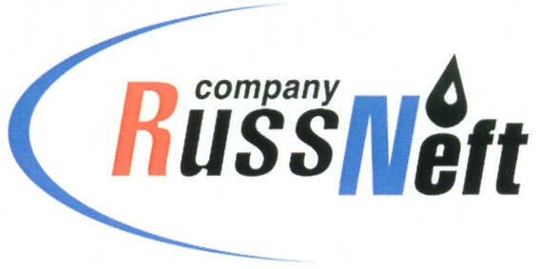
PJSC “RUSSNEFT” PRESS SERVICE

Tel.: (495) 411-63-24; (495) 411-63-21  Fax: (495) 411-63-19  E-mail: pr@russneft.ru  www.russneft.ru | 115054, Moscow,  Pyatnitskaya str., 69

PRESS RELEASE
February 9, 2019

FC Neftyanik wins “Minifootball to School” regional stage

Sponsored Football Club Neftyanik (Novospasskoye workers settlement, Ulyanovsk Region) has been successfully participating in “Minifootball to School” All-Russia programme.
Trainees of the Club became winners in four age groups, having been followed by their peers from Ulyanovsk and Dimitrovgrad. In the competitions the Club was represented by both boys (born in 2003-2006) and girls (born in 2005-2008). The young football players won the right to protect the honour of Ulyanovsk Region at the interregional stage in Nizhny Novgorod which will be held in February, 2019.
FC Neftyanik was founded in 2003 in worker`s settlement Novospasskoye with support of PJSC RussNeft`s founder and owner Mikhail Gutseriev. The Company has provided sponsorship to the Club for over 15 years now. More than 200 children of Novospassky district aged 7 to 17, many of whom are the children of employees of OAO Ulyanovskneft that is a subsidiary of the Company, attend the Club. Now it is the only club in the region, where training sessions, outfitting, sports equipment, and participation in all competitions are complimentary for the trainees.
Neftyanik`s young football players repeatedly became winners and medalists in regional, All-Russia and international tournaments.

About the Company:
PJSC “RussNeft” ranks among the Top-10 largest oil companies by crude oil production in Russia.
The Company possesses a well-balanced portfolio of assets located in the key Russian oil and gas provinces (West Siberia, Volga-Urals and Central Siberia) as well as in Azerbaijan.
The number of the Company’s personnel is around 10,000.

PJSC “RussNeft” Press Service
Tel.: (495) 411-63-24, Fax: (495) 411-63-19
E-mail: pr@russneft.ru

