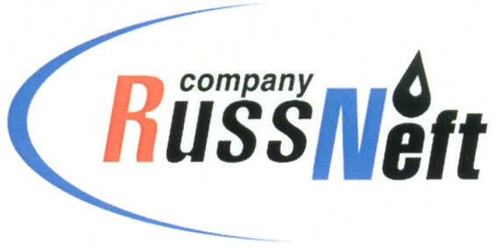
PJSC “RUSSNEFT” PRESS SERVICE

Tel.: (495) 411-63-24; (495) 411-63-21  Fax: (495) 411-63-19  E-mail: pr@russneft.ru  www.russneft.ru | 115054, Moscow,  Pyatnitskaya str., 69

PRESS-RELEASE
February 19, 2020

RussNeft supports the project for preserving cultural traditions of the indigenous minorities of the North

OAO MPK Aganneftegazgeologiya, PJSC “RussNeft” producing subsidiary, continues implementing its charitable projects for preserving and developing cultural traditions of the indigenous minorities of the North.
The charitable action included financial support provided to the National Crafts Center (Agan village, Nizhnevartovsk region). The funds were allocated for organization and performance of celebrations for the indigenous minorities of the North living at the territory of Nizhnevartovsk district, among them Hunters and Reindeer Herders Day, The Grey Crow Day, Autumn Celebration, etc.
Traditionally the joint stock company established special prizes in the professional skills contest among the reindeer herders for Yugra Governor’s Cup. The major event will be held in Khanty-Mansiysk in early March. It will attract the best reindeer herders of Khanty-Mansi Autonomous Region from Berezovsky, Beloyarsky, Surgutsky, Nizhnevartovsk and Khanty-Mansi districts. The Company’s active participation in preparations of this event was recognized by the letters of thanks from the government of the region.
The company allocated 350 thousand RUB for promotion of the original and traditional facilities of the indigenous minorities of Yugra.
Aganneftegazgeologiya produces hydrocarbons on the land related to the territories traditionally used by the 58 families, which comprise the indigenous minorities of the North. The joint stock company puts preserving the culture, traditions and customs indigenous minorities of Yugra as one of the priorities among other social projects.

About Company:y:
PJSC “RussNeft” ranks among the top-10 largest oil companies by crude oil production in Russia.
The Company possesses a well-balanced portfolio of assets located in the key Russian oil and gas provinces (West Siberia, Volga-Urals and Central Siberia) as well as in Azerbaijan.
The headcount of the Company is around 10,000 employees.

Press Service of PJSC "RussNeft"
Phone: (495) 411-63-24, Fax: (495) 411-63-19
E-mail: pr@russneft.ru

