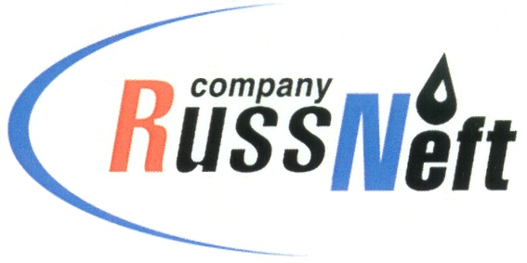

PJSC “RUSSNEFT” PRESS SERVICE

PRESS-RELEASE
Tel.: (495) 411-63-24; (495) 411-63-21  Fax: (495) 411-63-19  E-mail: pr@russneft.ru  www.russneft.ru | 115054, Moscow,  Pyatnitskaya str., 69

PRESS-RELEASE
April 26, 2017

PJSC “RussNeft” has fulfilled its commitments to oil production cuts

By the mid-April, PJSC “RussNeft” fulfilled its obligations to cut the oil production under the agreement between the Russian Federation, OPEC countries and non-OPEC countries which have adhered to this agreement.
2017 operation plan of the Company changes the production pattern in order to increase the profit margin. First of all, it relates to shutting down the inefficient wells.
It is anticipated that target production level for 2017 will not be lower than in 2016.

About the Company:
PJSC “RussNeft” ranks among the Top-10 largest oil companies by crude oil production in Russia.
The Company possesses a well-balanced portfolio of assets located in key Russian oil&gas provinces (West Siberia, Volga-Urals and Central Siberia) as well as in Azerbaijan.
Total 2P reserves of the Company exceed 200 mln tons (SPE). The number of the Company’s employees is around 10,000.
Information below may not be distributed outside of the Russian Federation. This document is released for information purposes only and, therefore, does not constitute and may not construed as an offer or an invitation to make an offer or information for executing any transactions, including transactions with securities or transactions intending to use or transfer securities or any interest therein. The information below contains «forward-looking statements», which include the description of intentions and plans in relation to the shares of Public Joint Stock Company «RussNeft» and can change from time to time, and does not constitute and may not construed as advertisement of securities, promise or guarantee of the sale of securities or any assets, placement or offering of the securities or entry into any contract. This document contains personal assessments of the management, which may differ from those of third parties. An investor should evaluate his/her own risks while taking any investment decisions.

PJSC “RussNeft” Press Service
Tel.: (495) 411-63-24, Fax: (495) 411-63-19
E-mail: pr@russneft.ru

