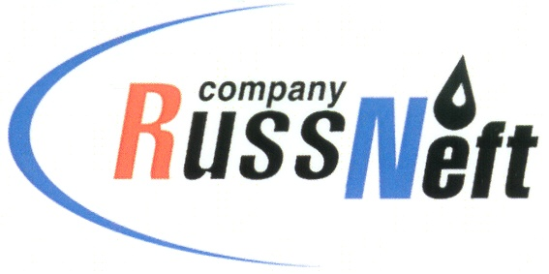
PJSC “RUSSNEFT” PRESS SERVICE

Tel.: (495) 411-63-24; (495) 411-63-21  Fax: (495) 411-63-19  E-mail: pr@russneft.ru  www.russneft.ru | 115054, Moscow,  Pyatnitskaya str., 69

PRESS - RELEASE
April 14, 2026

RussNeft continues to implement educational projects

Schoolchildren from the regions where PJSC “RussNeft” operates took part in an educational project implemented by the Company jointly with the Gubkin Russian Oil and Gas University since 2010.

The project aims to prepare applicants for the Unified State Exam (USE) for successful admission to higher education institutions.

The intensive course is taught online by Gubkin University teachers, significantly expanding the range of participants to gain additional knowledge in majors.

One of the strategic objectives of this educational project is to train high-end professionals for oil and gas industry, including for RussNeft enterprises.

This educational project is an important component of the corporate social responsibility policy.

About the Company:
PJSC “RussNeft” ranks among the top-10 largest oil companies by crude oil production in Russia.
The Company possesses a well-balanced portfolio of assets located in the key Russian oil and gas provinces (West Siberia, Volga-Urals and Central Siberia).
The headcount of the Company is around 6,000 employees.

Press Service of PJSC "RussNeft"
Phone: (495) 411-63-24,
Fax: (495) 411-63-19
E-mail: pr@russneft.ru

