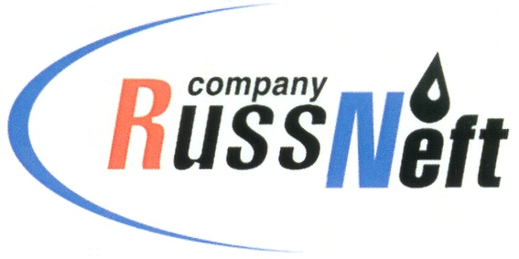
PJSC “RUSSNEFT” PRESS SERVICE

Tel.: (495) 411-63-24; (495) 411-63-21  Fax: (495) 411-63-19  E-mail: pr@russneft.ru  www.russneft.ru | 115054, Moscow,  Pyatnitskaya str., 69

PRESS - RELEASE
October 23, 2026

RussNeft is restoring forests in Western Siberia

In 2026, PJSC “RussNeft” increased the volume of reforestation work by another 171 hectares (ha). Thus, since 2017, the planting of new trees has covered an area of 875 ha, with more than 3,272,000 seedlings planted.

In addition, agrotechnical care was provided for previously planted seedlings on an area of 264 ha.

When reproducing forests, RussNeft uses improved and varietal seeds of forest plants adapted to the regional characteristics of the planting area. For the restoration of forest areas in Western Siberia, pine seedlings are usually used; they are pre‑grown in nurseries to a height of 12–20 cm.

The reforestation programme is implemented on territories allocated by forest districts to compensate for deforestation at infrastructure construction sites for oil production.

RussNeft pays close attention to compliance with environmental legislation and to preventing the negative impact of its production activities on the environment.

About the Company:

PJSC “RussNeft” ranks among the top-10 largest oil companies by crude oil production in Russia.

The Company possesses a well-balanced portfolio of assets located in the key Russian oil and gas provinces (West Siberia, Volga-Urals and Central Siberia).

The headcount of the Company is over 6,000 employees.

Press Service of PJSC "RussNeft"
Phone: (495) 411-63-24, Fax: (495) 411-63-19
E-mail: pr@russneft.ru

