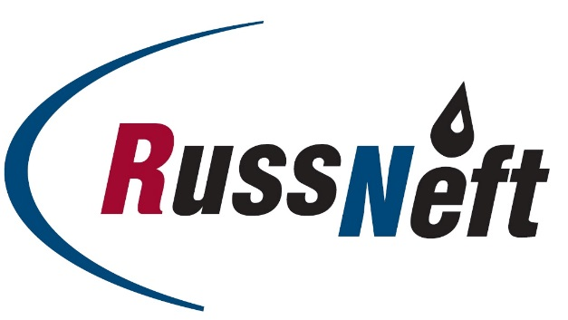
PJSC “RUSSNEFT” PRESS SERVICE

Tel.: (495) 411-63-24; (495) 411-63-21  Fax: (495) 411-63-19  E-mail: pr@russneft.ru  www.russneft.ru | 115054, Moscow,  Pyatnitskaya str., 69

PRESS RELEASE
December 26, 2018

RussNeft produces 7.1 million tonnes of oil and 2.6 billion cubic meters of gas in 2018

PJSC “RussNeft” is expected to produce over 7.110 million tonnes of oil and about 2.616 billion cubic meters of gas in 2018.
In the reporting year, 139 new oil wells were put into operation in the Company’s fields adding 970 thousand tonnes of production.
Besides, RussNeft has successfully carried out a two-casing well construction project to reach Achimov deposits in Tagrinskoye field this year. This allowed significantly faster drilling and lining reducing the costs.
First in Russia, the Company developed and applied (jointly with OOO TCC) the technology for multi-phase hydro-fracking in a 146 mm casing (initially, with 75 degrees entry angle which will be up to 90 degrees by the year end).
The time between overhauls of the ESP-equipped wells is expected to be 639 days in 2018 which is 12.3% more against the previous year and 5% above the plan.
Application of the investments in 2018 is fully compliant with the business plan parameters.

Besides

About the Company:

PJSC “RussNeft” ranks among the Top-10 largest oil companies by crude oil production in Russia.
The Company possesses a well-balanced portfolio of assets located in the key Russian oil and gas provinces (West Siberia, Volga-Urals and Central Siberia) as well as in Azerbaijan.
The number of the Company’s personnel is around 10,000.

PJSC “RussNeft” Press Service
Tel.: (495) 411-63-24, Fax: (495) 411-63-19
E-mail: pr@russneft.ru

