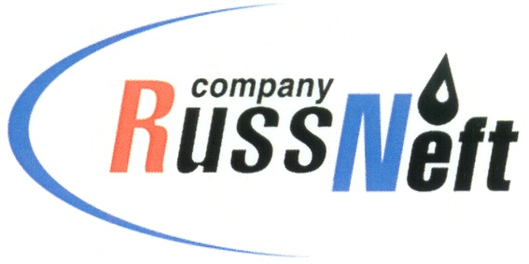

March 28, 2018

PJSC “RussNeft” publishes 2017 financial results under IFRS

PJSC “RussNeft” (“RussNeft” or “Company”) (MOEX: RNFT), one of the largest oil companies in Russia by oil production, publishes its audited consolidated financial statement for the year, ended on December 31, 2017, prepared in accordance with the International Financial Reporting Standards (IFRS).

Key events:
- EBITDA grew 18% up to RUB 29.9 billion in 2017.
- The adjusted net profit amounted to RUB 11.1 billion, 333% growth.
- The oil production was 7.5 million tonnes.
- High-margin oil production grew to up to 34% of the total volume.
- Consistent increase of the capital investments, the 2017 investments amounted to RUB 25.7 billion.
- The Company’s securities were included into the main indices of the Moscow Exchange.
- The Net Debt/EBITDA ratio was 2.7.

Key performance results
Financial indicators
RUB bln | 2017 | 2016 | Change
Revenue | 129.2 | 105.0 | 23%
EBITDA | 29.9 | 25.2 | 18%
OIBDA | 30.8 | 25.8 | 20%
Net profit | 7.3 | 13.4 | (45%)
Adjusted net profit | 11.1 | 2.6 | 333%
Net debt | 79.5 | 82.0 | (3%)

In 2017, “RussNeft” demonstrated significant growth of financial indicators with stable production. Revenue increased by 23% to RUB 129.2 billion and EBITDA amounted to RUB 29.9 billion, up 18% from the previous year. The main cause of the increase in revenues and EBITDA was a significant rise of the oil prices, as well as the growth of high-margin oil production to 34% of the total volume.
Net profit amounted to RUB 7.3 billion, which is 45% lower than the last year. The decrease in profit was due to a significant effect on the positive foreign exchange differences in 2016, as well as a "paper" loss on revaluation of the fair value of derivative financial instruments.
Adjusted net profit excluding these factors shows a 4.3-fold increase, reflecting a significant improvement in the operating profile of “RussNeft” in 2017.
Operating results
Operating results | 2017 | 2016 | Change
Oil production | 7 516 | 7 502 | 0%
Oil production in RF, million tonnes | 7 015 | 7 001 | 0%
Oil production under PSA’s, thousand tonnes | 501 | 501 | 0%
Gas production, m3 | 2 448 | 2 479 | 0%

The volume of oil and gas production in 2017 was at the level of 2016. Management's efforts were aimed at maintaining the current rate of hydrocarbon production, as well as reducing costs by involving high margin reserves in the development. Thus, the share of high-margin oil in the volume of the Company's production amounted to about 34% in the reporting year.
Capital investments
Capital investments (application), RUB billion | 25.7 | 17.3 | 48%
PRODUCTION DRILLING | 18.6 | 12.9 | 44%
BASIC PRODUCTION | 2.2 | 1.8 | 22%
WELL INTERVENTIONS | 1.9 | 1.8 | 7%
GAS PROGRAM | 2.3 | 0.7 | 232%
EXPLORATION | 0.7 | 0.1 | 431%

The Company's strategy provides for active investment activities aimed at increasing exploration, drilling and commissioning of new wells, creation of new and upgrade of the existing infrastructure in order to maintain the existing production rates, as well as achieving organic growth in the medium term. The volume of investments in 2017 amounted to RUB 25.7 billion, which is higher than in 2016 by 49% or RUB 8.4 billion rubles.
Debt portfolio
The Company's net debt in the reporting year amounted to RUB 79.5 billion. Main creditor was VTB Bank (PJSC). A slight change (3%) is mainly due to the strengthening of the ruble in 2017. Thanks to the coordinated work of the management and shareholders, the Company has achieved the target indicators for compliance with financial and production covenants, the interest payments on the loan were performed in a timely manner and in full.

The full version of the Financial Statement under IFRS is available at:
http://russneft.ru/shareholders/financial_statements/
Contacts for Mass-Media  +7 (495) 411- 63- 24  pr@russneft.ru | Contacts for investors  +7 (495) 411-63-09  ir@russneft.ru

About the Company:
PJSC “RussNeft” ranks among the largest oil companies by crude oil production in Russia.
The Company possesses a well-balanced portfolio of assets located in the key Russian oil and gas provinces (West Siberia, Volga-Urals and Central Siberia) as well as in Azerbaijan.
The company’s 2P reserves are over 200 million tonnes (SPE). The number of the Company’s personnel is around 10,000.
The charter capital of the Company consists of 294 120 000 ordinary shares and 98 032 000 preferred shares, whilst 20% of the voting shares are traded at the Moscow Exchange (MOEX: RNFТ).

W/o accounting for currency exchange differences and financial instruments fair value readjustment
Including production from international projects
EBITDA does not account for the currency exchange differences and nonmonetary items
OIBDA does not account for other operational expenses and nonmonetary items
W/o accounting for currency exchange differences and financial instruments fair value readjustment
W/o accounting for the reserves under the international projects

