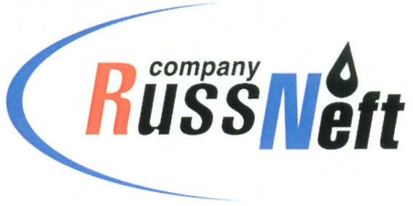

PJSC “RUSSNEFT” PRESS SERVICE

Tel.: (495) 411-63-24; (495) 411-63-21  Fax: (495) 411-63-19  E-mail: pr@russneft.ru  www.russneft.ru | 115054, Moscow,  Pyatnitskaya str., 69
PRESS RELEASE
April 19, 2022

RussNeft continues to implement charitable projects in Saratov

PJSC "RussNeft" continues to implement the already traditional project "We are children of space" on the basis of the children's recreation center Rovesnik in the Marksovsky district of the Saratov region.

For the seventh time in the April "space" shift, 120 children visited the children's center sponsored by the Saratov branch of the Company: schoolchildren from Saratov, Engels and the municipal districts of the region, as well as students of the vocational and pedagogical college of Gagarin Saratov State Technical University.

The project program traditionally included educational, sports, entertainment and creative events: master classes, presentations, lectures, trainings, concerts, sports events, flash mobs, quizzes, hobby groups, evening discos.

The unique content of the project is still its guests of honor, whose fate is connected with the conquest of the sky: first of all, these are cosmonauts, testers, scientists, inventors, athletes. This time, V.A. Ren, Hero of the Russian Federation, Deputy Head of the Department of Gagarin Cosmonaut Training Center, and M.A. Potapov, Vice-President of the Russian Parachuting Federation, Honored Coach of the Russian Federation, Senior Coach of the Russian National Team.

V.N. Rzhevsky, Head of the Department of Architecture of Surikov Moscow State Academic Art Institute, Honored Architect of the Russian Federation, Academician of the Russian Academy of Arts, Deputy Chairman of the Charitable Foundation in Memory of the First Cosmonaut of the Earth, spoke about the reflection of the history of space exploration in creativity and art.

On Cosmonautics Day, April 12, another significant event took place - the official ceremony of canceling postage stamps: a joint action of Rovesnik and Russian Post. Each participant of the project took home a unique postal souvenir with autographs of honored guests, a lot of interesting photos and unforgettable impressions.

About the Company:
PJSC “RussNeft” ranks among the top-10 largest oil companies by crude oil production in Russia.
The Company possesses a well-balanced portfolio of assets located in the key Russian oil and gas provinces (West Siberia, Volga-Urals and Central Siberia) as well as in Azerbaijan.
The headcount of the Company is around 8,000 employees.

PJSC “RussNeft” Press Service
Tel.: (495) 411-63-24, Fax: (495) 411-63-19
E-mail: pr@russneft.ru

