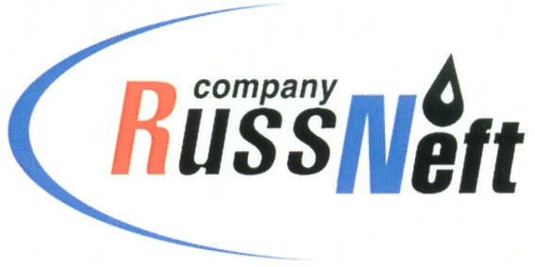
PJSC “RUSSNEFT” PRESS SERVICE

Tel.: (495) 411-63-24; (495) 411-63-21  Fax: (495) 411-63-19  E-mail: pr@russneft.ru  www.russneft.ru | 115054, Moscow,  Pyatnitskaya str., 69

PRESS RELEASE
November 3, 2021

RussNeft allocates RUB 20 mln to support Ugra indigenous people

PJSC RussNeft allocated more than RUB 20 mln in 2021 for compensation payments to the small indigenous peoples of the North.
The Nizhnevartovsk branch of RussNeft extracts hydrocarbons within the Nizhnevartovsk and Surgut districts of KhMAO-Yugra on the lands belonging to the 10 territories of traditional nature use for 59 indigenous families.
Compensation payments are designated for the purchase of equipment, construction materials, fuel and other stock needed in forest camps.
The compensation agreements are not the only example of mutually beneficial cooperation between oil workers and indigenous communities of the North. This year, under the program of social and economic development of the territory, the Company provided financial support to the Inter-settlement Center of Ethnic Handicrafts and Trades (Agan rural settlement, Nizhnevartovsky district), to international proficiency competition among reindeer herders, scheduled for late 2021.

RussNeft will continue funding programs aimed at supporting and preserving the distinctive culture, traditions and customs of the indigenous population of Ugra.

About the Company:

PJSC “RussNeft” ranks among the top-10 largest oil companies by crude oil production in Russia.
The Company possesses a well-balanced portfolio of assets located in the key Russian oil and gas provinces (West Siberia, Volga-Urals and Central Siberia) as well as in Azerbaijan.
The headcount of the Company is around 8,000 employees.

PJSC “RussNeft” Press Service
Tel.: (495) 411-63-24, Fax: (495) 411-63-19
E-mail: pr@russneft.ru

