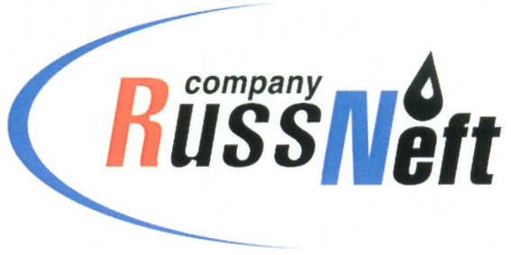
PJSC “RUSSNEFT”
PRESS SERVICE

Tel.: (495) 411-63-24; (495) 411-63-21  Fax: (495) 411-63-19  E-mail: pr@russneft.ru  www.russneft.ru | 115054, Moscow,  Pyatnitskaya str., 69

PRESS - RELEASE
February 18, 2021
RussNeft resumes drilling at Vostochno-Kamennoye field

PJSC “RussNeft” starts preparations for implementing the advance drilling program at Vostochno-Kamennoye field of Vodorazdelny license.
During the winter period of 2021 it is planned to bring the mobile drilling rig to drill 3 directional wells with core sampling from producing formations of Tuymen suite. The cumulative remaining recoverable reserves from formations of Tyumen suite presumably make up around 14 mln tons and have low permeability and poor continuity.
RussNeft has gained a similar experience at Peschaniy and Shapshinskaya group of fields, which allows the Company to increase profitability of construction of the new wells to the maximum by means of extending the horizontal sections and multifracs.
There are 2 active pads at Vostochno-Kamennoye at the moment, which are ready to receive the mobile rig.
The wells drilled in 2021 will be tested, stimulated and flowback operations will be performed in winter time in 2022.

About the Company:
PJSC “RussNeft” ranks among the top-10 largest oil companies by crude oil production in Russia.
The Company possesses a well-balanced portfolio of assets located in the key Russian oil and gas provinces (West Siberia, Volga-Urals and Central Siberia) as well as in Azerbaijan.
The headcount of the Company is around 10,000 employees.

Press Service of PJSC "RussNeft"
Phone: (495) 411-63-24
Fax: (495) 411-63-19
E-mail: pr@russneft.ru

