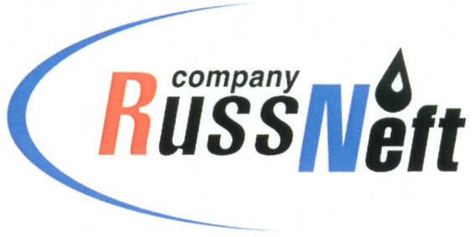
PJSC “RUSSNEFT”
PRESS SERVICE

Tel.: (495) 411-63-24; (495) 411-63-21  Fax: (495) 411-63-19  E-mail: pr@russneft.ru  www.russneft.ru | 115054, Moscow,  Pyatnitskaya str., 69

PRESS - RELEASE
October 19, 2020
“RussNeft” resumes drilling at the oil fields of Variogan block in October

PJSC “RussNeft” resumes production drilling at Variogan oil block.
By the end of 2020 the company plans to put into operation 5 oil wells at Achimov deposits of Tagrinskoye field and 4 wells are after side-tracking.
Production drilling at Variogan oil block was suspended in connection with production restrictions under OPEC+ deal. Starting from the 1st October the Company made a resolution on resumption of the works.
In 2020 PJSC “RussNeft” plans to put into operation 24 new wells and 12 wells after side-tracking. Implementation of these activities will secure the Company’s output increase in the amount of 195 923 k tons.
These steps will allow to flatten out the levels of production at the Block in 2020 and solid growth of production indicators in 2021.

About company:
PJSC “RussNeft” ranks among the top-10 largest oil companies by crude oil production in Russia.
The Company possesses a well-balanced portfolio of assets located in the key Russian oil and gas provinces (West Siberia, Volga-Urals and Central Siberia) as well as in Azerbaijan.
The headcount of the Company is around 10,000 employees.

Press Service of PJSC "RussNeft"
Phone: (495) 411-63-24
Fax: (495) 411-63-19
E-mail: pr@russneft.ru

