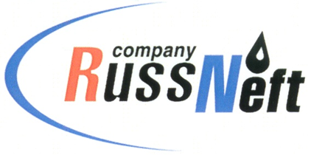
PJSC “RUSSNEFT” PRESS SERVICE

Tel.: (495) 411-63-24; (495) 411-63-21  Fax: (495) 411-63-19  E-mail: pr@russneft.ru  www.russneft.ru | 115054, Moscow,  Pyatnitskaya str., 69

PRESS RELEASE
November 8, 2019

RussNeft - Gubkin RSU implementing joint educational project

RussNeft together with Gubkin RSU continues to implement a project for preparing the school students for admission to the university. Teaching the future enrollees at the Regional Preparatory Courses will take place in Saratov and Raduzhny cities.
RSU is expected to hold two visiting sessions for school graduates enabling the latter to prepare for the exams and admission to the university in the most effective way.
In 2019 the courses are to be held for the tenth time and would gather 56 students from the regions of the Company`s operation.
Not just the children of the holding`s employees, but also school children from the remote districts of the Saratov Region and KhMAO will be able to get trained for admission.
Apart from visiting the lessons in person, the youngsters would exercise self-assignments with the materials provided by Pre-University Educational and Research Centre with preliminary testing afterwards.
The joint project is a part of the RussNeft educational programme and designed not only to contribute to the preparation of the industry`s labour force, but also to enhance the educational level of school students.

About the Company:

PJSC "RussNeft" is among the top 10 largest oil companies in terms of oil production in Russia.
The company has a balanced portfolio of assets in Russia in key oil and gas regions (Western Siberia, Volga-Ural region and Central Siberia), as well as in Azerbaijan.
The number of employees of the Company is about 10, 000 people.

PJSC “RussNeft” Press Service
Tel.: (495) 411-63-24, Fax: (495) 411-63-19
E-mail: pr@russneft.ru

