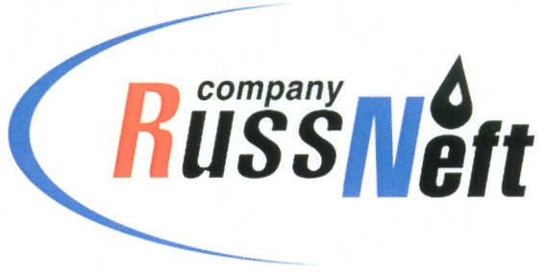

PJSC “RUSSNEFT” PRESS SERVICE

Tel.: (495) 411-63-24; (495) 411-63-21  Fax: (495) 411-63-19  E-mail: pr@russneft.ru  www.russneft.ru | 115054, Moscow,  Pyatnitskaya str., 69

PRESS RELEASE
June 7, 2022

RussNeft took part in the international action "Garden of Memory"

The Khanty-Mansiysk branch of PJSC “RussNeft” took part in the international action "Garden of Memory". More than 20 branch employees took part in the traditional memorial tree planting, which took place at the 23rd kilometer of the Khanty-Mansiysk-Nyagan highway near the Baibalak River. The international campaign involves the planting of 27 million trees in Russia in memory of each of the 27 million who died on the battlefields of the Great Patriotic War.

The action takes place in 2022 for the third time: "green monuments" are a living reminder of those who did not return from the war, fighting for the freedom of their homeland.

Since the beginning of the campaign, more than 25 million trees have already been planted throughout Russia.

About the Company:
PJSC “RussNeft” ranks among the top-6 largest oil companies by crude oil production in Russia.
The Company possesses a well-balanced portfolio of assets located in the key Russian oil and gas provinces (West Siberia, Volga-Urals and Central Siberia) as well as in Azerbaijan.
The headcount of the Company is around 8,000 employees.

PJSC “RussNeft” Press Service
Tel.: (495) 411-63-24, Fax: (495) 411-63-19
E-mail: pr@russneft.ru

