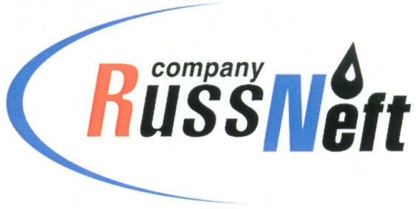
PJSC “RUSSNEFT”
PRESS SERVICE

Tel.: (495) 411-63-24; (495) 411-63-21  Fax: (495) 411-63-19  E-mail: pr@russneft.ru  www.russneft.ru | 115054, Moscow,  Pyatnitskaya str., 69

PRESS - RELEASE
October 12, 2021
RussNeft continues joint educational project with Gubkin Russian State University of Oil and Gas

PJSC “RussNeft” continues to implement the joint educational project with the Gubkin Russian State University of Oil and Gas to prepare school students for the Unified State Exam and admission to universities.
Future applicants will receive additional knowledge during regional preparatory courses (RPC), where classes are taught by university educators.
The joint project, being implemented since 2010, will be hosted by the Saratov and Nizhnevartovsk branches of RussNeft.
Following the tradition, in the 2021/2022 academic year, the RPC participants will be selected from among students of high schools and special educational institutions. Due to COVID-19 sanitary restrictions, the courses will be delivered online. Two sessions are scheduled.

About the Company:
PJSC “RussNeft” ranks among the Top 6 largest oil companies by crude oil production in Russia.

The Company possesses a well-balanced portfolio of assets located in the key Russian oil and gas provinces (West Siberia, Volga-Urals and Central Siberia) as well as in Azerbaijan.

The Company's 2P reserves exceed 200 million tonnes (SPE). The headcount of the Company is around 8,000 employees.

Press Service of PJSC "RussNeft"
Phone: (495) 411-63-24
Fax: (495) 411-63-19
E-mail: pr@russneft.ru

