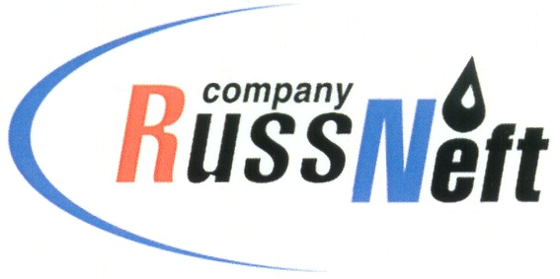
PJSC “RUSSNEFT” PRESS SERVICE

Tel.: (495) 411-63-24; (495) 411-63-21  Fax: (495) 411-63-19  E-mail: pr@russneft.ru  www.russneft.ru | 115054, Moscow,  Pyatnitskaya str., 69

PRESS RELEASE

September 22, 2020

RussNeft will build a new gas treatment plant in Saratov

PJSC “RussNeft” is finalizing design documentation for construction of a new gas treatment plant (GTP) in Saratov region.

The facility will be constructed within the Company's gas program and is designed to receive up to 25 billion cubic meters of gas from Pogranichny oil and gas condensate field.

The Company intends to supply the gas from the new GTP, which will be built at the Vostochno-Rybushanskoe gathering station, to Gazprom gas transportation system.

RussNeft's gas reserves are estimated at 151 billion cubic meters. The Company's annual gas production is about 2.4 billion cubic meters.

About the Company:

PJSC “RussNeft” ranks among the top-10 largest oil companies by crude oil production in Russia.
The Company possesses a well-balanced portfolio of assets located in the key Russian oil and gas provinces (West Siberia, Volga-Urals and Central Siberia) as well as in Azerbaijan.
The headcount of the Company is around 10,000 employees.

PJSC “RussNeft” Press Service
Tel.: (495) 411-63-24, Fax: (495) 411-63-19
E-mail: pr@russneft.ru

