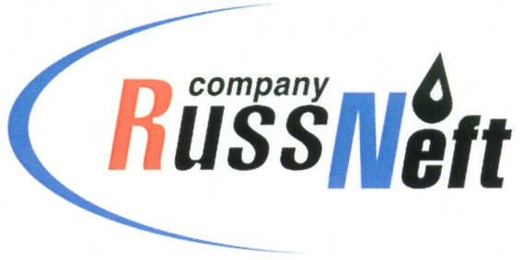
PJSC “RUSSNEFT” PRESS SERVICE

Tel.: (495) 411-63-24; (495) 411-63-21  Fax: (495) 411-63-19  E-mail: pr@russneft.ru  www.russneft.ru | 115054, Moscow,  Pyatnitskaya str., 69

PRESS RELEASE
June 15, 2020

RussNeft expects significant growth of resource base at Tagrinskoye oilfield

Growth of recoverable reserves at Tagrinskoye oilfield of RussNeft may amount to 10 million tons.

In 2019-2020, the Company carried out field seismic survey MOGT-3D over 280 square kilometers on the eastern flank and to the south of Vostochno-Kalinovsky area of the oilfield. The seismic results allowed the Company's geologists to calculate that each of the blocks could provide a 5 million ton increment in reserves.

RussNeft received licenses for geological study of new sections of Tagrinskoye oilfield in 2018 and in 2019.

Tagrinskoye oil and gas condensate field is located in Nizhnevartovsk District of Khanty-Mansi Autonomous Area-Yugra and partially in Purovsky District of Yamalo-Nenets Autonomous Area. The prospects for further development of the Tagrinskoye field are connected with the development of Achimov deposits.

About the Company:

PJSC “RussNeft” ranks among the top-6 largest oil companies by crude oil production in Russia.
The Company possesses a well-balanced portfolio of assets located in the key Russian oil and gas provinces (West Siberia, Volga-Urals and Central Siberia) as well as in Azerbaijan.
The headcount of the Company is around 10,000 employees.

PJSC “RussNeft” Press Service
Tel.: (495) 411-63-24, Fax: (495) 411-63-19
E-mail: pr@russneft.ru

