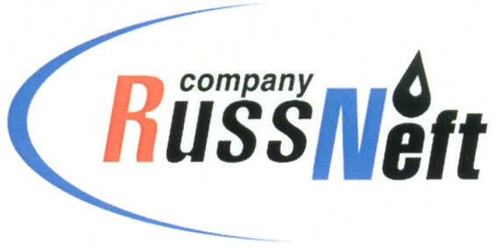
PJSC “RUSSNEFT”
PRESS SERVICE

Tel.: (495) 411-63-24; (495) 411-63-21  Fax: (495) 411-63-19  E-mail: pr@russneft.ru  www.russneft.ru | 115054, Moscow,  Pyatnitskaya str., 69

PRESS - RELEASE
March 15, 2021
Support of cultural traditions of the North indigenous peoples is again among RussNeft's charitable projects

PJSC «RussNeft» took part in charity programs aimed at promoting original culture and traditional economy of indigenous peoples of Khanty-Mansi Autonomous Okrug - Ugra.
The Сompany donated 450,000 rubles for financial support of organizations whose activities are aimed at revival, preservation and development of folk arts and crafts, traditional crafts, preservation and continuity in the development of ancient traditions of small peoples of the North. Among them are the Inter-settlement Center of National Trades and Crafts in the Agan Village and the "Saving Ugra" Public Organization.
RussNeft is a traditional sponsor in organizing and holding folk festivals of indigenous peoples of the North, which are held annually in the settlements of Nizhnevartovsk district: "Day of Hunter and Reindeer Breeder", "Day of Grey Crow Arrival", "Autumn Holiday" and others. The Okrug Contest of Professional Mastery among reindeer breeders for the Ugra Governor's Cup is held with the financial support of the Company.

About the Company:
PJSC “RussNeft” ranks among the top-10 largest oil companies by crude oil production in Russia.
The Company possesses a well-balanced portfolio of assets located in the key Russian oil and gas provinces (West Siberia, Volga-Urals and Central Siberia) as well as in Azerbaijan.
The headcount of the Company is around 10,000 employees.

Press Service of PJSC "RussNeft"
Phone: (495) 411-63-24
Fax: (495) 411-63-19
E-mail: pr@russneft.ru

