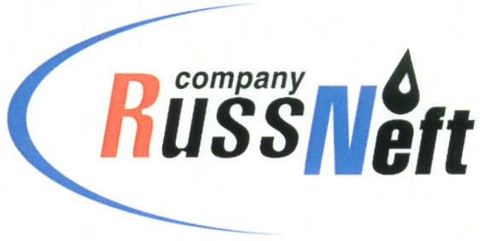
PJSC “RUSSNEFT” PRESS SERVICE

Tel.: (495) 411-63-24; (495) 411-63-21  Fax: (495) 411-63-19  E-mail: pr@russneft.ru  www.russneft.ru | 115054, Moscow,  Pyatnitskaya str., 69

PRESS - RELEASE
March 28, 2023

RussNeft handed over equipment to a sponsored technical school

The Ulyanovsk branch of PJSC "RussNeft" donated equipment to the sponsored Ryazan Technical School for the purpose of using it as a visual aid for future oil industry specialists.

The Company and the technical school cooperate in the field of training mid-level specialists for the oil industry of the region and jointly implement an educational program in the specialty "Development and operation of oil and gas fields."

As part of the cooperation program, students are given tours at the Company's production facilities to get acquainted with oil production processes.

The Ulyanovsk branch of PJSC “RussNeft” systematically implements charitable and sponsorship programs in the areas of its operation. It contributes to the development of the social sphere of the region, and also provides targeted support to people in need.

About the Company:
PJSC “RussNeft” ranks among the top-10 largest oil companies by crude oil production in Russia.
The Company possesses a well-balanced portfolio of assets located in the key Russian oil and gas provinces (West Siberia, Volga-Urals and Central Siberia) as well as in Azerbaijan.
The headcount of the Company is around 8,000 employees.

Press Service of PJSC "RussNeft"
Phone: (495) 411-63-24,
Fax: (495) 411-63-19
E-mail: pr@russneft.ru

