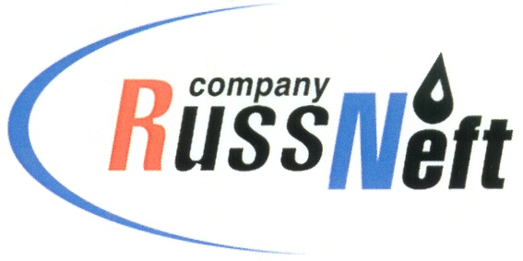
PJSC “RUSSNEFT” PRESS SERVICE

Tel.: (495) 411-63-24; (495) 411-63-21  Fax: (495) 411-63-19  E-mail: pr@russneft.ru  www.russneft.ru | 115054, Moscow,  Pyatnitskaya str., 69

PRESS - RELEASE
September 25, 2026

RussNeft Continues to Support Sports Events in the Regions

PJSC “RussNeft” continues to support regional sports initiatives. In the Khanty-Mansi Autonomous Okrug – Yugra, the Company supported the Open Boxing Championship for the Nizhnevartovsky District Head’s Cup.
More than 120 athletes took part in the tournament. Boxers from the Nizhnevartovsky District, Surgut, Nefteyugansk, Megion, Nizhnevartovsk, Lyanotor, Langepas, as well as the Sverdlovsk and Tomsk oblasts competed in the ring.
Additionally, with RussNeft’s support, the sponsored children's football club "Neftyanik" took first place in the "Finist Summer Cup," an all-Russian youth football tournament, successfully winning all matches in its age group (7–8 years old). Young athletes from Ulyanovsk also secured second place in the group stage of the 6th "Battle of the Regions" all-Russian football tournament.
RussNeft continues to implement social programs in the regions of its operational presence. The football club "Neftyanik" was established in 2003 in the working settlement of Novospasskoye, Novospassky district, Ulyanovsk oblast, with the support of RussNeft. The club trains more than 200 children aged 7 to 17.

About the Company:
PJSC “RussNeft” ranks among the top-10 largest oil companies by crude oil production in Russia.

The Company possesses a well-balanced portfolio of assets located in the key Russian oil and gas provinces (West Siberia, Volga-Urals and Central Siberia).
The headcount of the Company is around 7,000 employees.

Press Service of PJSC "RussNeft"
Phone: (495) 411-63-24, Fax: (495) 411-63-19
E-mail: pr@russneft.ru

