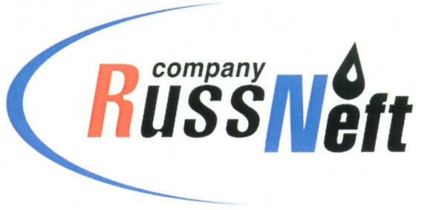
PJSC “RUSSNEFT” PRESS SERVICE

Tel.: (495) 411-63-24; (495) 411-63-21  Fax: (495) 411-63-19  E-mail: pr@russneft.ru  www.russneft.ru | 115054, Moscow,  Pyatnitskaya str., 69

PRESS RELEASE
August 20, 2019

RussNeft announces “Best in Profession-2019” contest results

The professional contest “Best in Profession-2019”of PJSC “RussNeft” has been held in Saratov. Saratovneftegaz, a subsidiary of RussNeft, whose employees were recognized as the best in 6 categories, became an overall winner.
66 specialists from Ulyanovsk and Khanty-Mansiysk branches of RussNeft, Aganneftegazgeologia, Tomskaya Neft, Varioganneft and Saratovneftegaz took part in the contest. Over two days, the oil and gas production operators, process pump operators, electric/gas welders, drivers, dehydrating and desalting units operators, oilfield equipment maintenance men, electrical machinery maintenance and repair men, chemistry lab technicians, instrumentation and automation technicians, and well service crews, competed for the right to be named the best of the best.
The competition was comprised of two rounds, the first of which offered 30 theoretical assignments for the contestants. In the second round, the participants had to demonstrate their skills in practice. All individual competition winners were awarded honorable mentions, commemorative badges with certificates, and cash prizes. The winning team from Saratovneftegaz was given the challenge cup.

About the Company:

PJSC “RussNeft” ranks among the top-10 largest oil companies by crude oil production in Russia.
The Company possesses a well-balanced portfolio of assets located in the key Russian oil and gas provinces (West Siberia, Volga-Urals and Central Siberia) as well as in Azerbaijan.
The headcount of the Company is around 10,000 employees.

PJSC “RussNeft” Press Service
Tel.: (495) 411-63-24, Fax: (495) 411-63-19
E-mail: pr@russneft.ru

