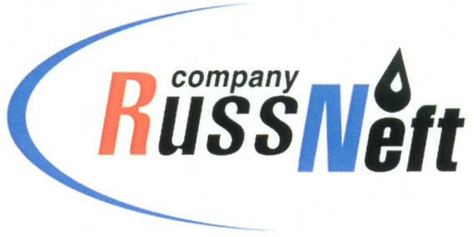
PJSC “RUSSNEFT” PRESS SERVICE

Tel.: (495) 411-63-24; (495) 411-63-21  Fax: (495) 411-63-19  E-mail: pr@russneft.ru  www.russneft.ru | 115054, Moscow,  Pyatnitskaya str., 69

PRESS RELEASE

September 4, 2019

RUSSNEFT SUPPORTS CHARITABLE PROJECTS IN ROVESNIK

A number of charitable projects were implemented this summer in Rovesnik Children`s Wellness Centre with support of PJSC “RussNeft” and its subsidiary Saratovneftegas.
“Volzhskaya Raduga 2019” Interregional Arts-Oriented Summer School for gifted children, youth and teachers for so many years have brought together talented musicians, artists, dancers and actors. This year it covered the following areas: "Instrumental Performance (Wind and Percussion Instruments)", "Art of Theater", "Fine Arts".
197 children, including young gymnasts of the Central Sports School, members of “Etual” Ballroom Dance Company, the "Young Dynamo" unarmed self-defence section of Saratov regional branch of Dynamo National Society, as well as young athletes from Marksovskiy and Perelyubskiy municipal districts took part in the project “We Choose Sports”. During stay in the charitable camp, children that are keen of rhythmic gymnastics, sports dances, unarmed self-defence and volleyball, spent their time not only in routine work-outs. Each of their days was full of interesting events, performances, shows, flash mobs, quizzes and "fun starts".
The winners of 17th All-Russia “The Best Master Class of Writing” competition designed to revive the Russian traditions of the epistolary genre and promote the Russian language, were involved in "One country - one postal service" charitable project. The project helped children in Rovesnik not just to learn more about the activities of FGUP Post of Russia as a socially oriented enterprise, but also to get acquainted with new projects and modern services the national postal operator provides.
Due to the close partnership with OOO SEPO-ZEM, Saratov Refinery, JSC KB Electropribor, Gazprom mezhregiongaz Saratov, Saratovorgsintez LLC, LocoTech-Service LLC, JSC Transneft Volga Region, JSC and Klever linguistic center, children of employees of enterprises and organizations of the entire region were able to gain strength and health in the Wellness Center.
The summer health campaign, which was attended by more than 1,000 school students, provided the children's center with fun contests, sport, educational and entertainment events, swimming and beach games, horse riding and pedal car driving, hobby clubs and discos, sports grounds and rides.

About the Company:

PJSC “RussNeft” ranks among the top-10 largest oil companies by crude oil production in Russia.
The Company possesses a well-balanced portfolio of assets located in the key Russian oil and gas provinces (West Siberia, Volga-Urals and Central Siberia) as well as in Azerbaijan.
The headcount of the Company is around 10,000 employees.

PJSC “RussNeft” Press Service
Tel.: (495) 411-63-24, Fax: (495) 411-63-19
E-mail: pr@russneft.ru

