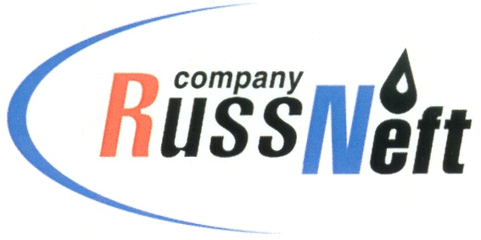
PJSC “RUSSNEFT” PRESS SERVICE
PRESS-RELEASE
Tel.: (495) 411-63-24; (495) 411-63-21  Fax: (495) 411-63-19  E-mail: pr@russneft.ru  www.russneft.ru | 115054, Moscow,  Pyatnitskaya str., 69

PRESS-RELEASE
April 17, 2018

Economic effect of Production Costs Optimisation Programme in 2017 is estimated at RUB 167 million

Since 2017 PJSC “RussNeft” has been implementing the Production Costs Optimisation Programme (PCO) which includes all the subsidiaries of the Company. One of the main purposes of the programme is to help the active employees to prove themselves by proposing an interesting novation idea for the Company. The introduction and implementation of the PCO Programme will enable the formation and accumulation of the experience of introduction of technical arrangements, organizational and administrative solutions that would substantially enhance the operations efficiency.
“RussNeft” has a coherent system of innovation support. The cost-cutting proposals are considered at the Section of the Scientific and Technical Review Council (STRC) of the Company. The ideas that require substantial investments are discussed at the STRC meetings under the chairmanship of the President of the Company.
In order to add a touch of rivalry to the process, a corporate contest was established in autumn 2017, where the authors of cost and processes optimization ideas took part. In early April 2018 the results of the contest were announced and the winners were awarded.
In 2017, 74 of new ideas of the employees of the subsidiaries were approved for implementation at the scientific and technical panels. The actual benefit for 2017 was amounted to RUB167 million.

About the Company:
PJSC “RussNeft” ranks among the Top-10 largest oil companies by crude oil production in Russia.
The Company possesses a well-balanced portfolio of assets located in the key Russian oil and gas provinces (West Siberia, Volga-Urals and Central Siberia) as well as in Azerbaijan.
The company’s 2P reserves are over 200 million tonnes (SPE).
The number of the Company’s personnel is around 10,000.

PJSC “RussNeft” Press Service
Tel.: (495) 411-63-24, Fax: (495) 411-63-19
E-mail: pr@russneft.ru

