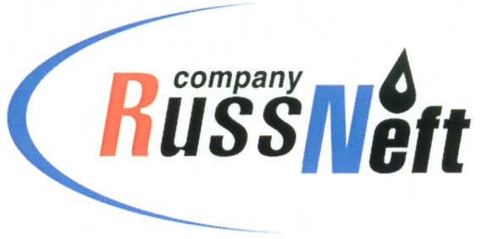
PJSC “RUSSNEFT” PRESS SERVICE

Tel.: (495) 411-63-24; (495) 411-63-21  Fax: (495) 411-63-19  E-mail: pr@russneft.ru  www.russneft.ru | 115054, Moscow,  Pyatnitskaya str., 69

PRESS RELEASE
August 12, 2021

RussNeft supports the social project "House of Diligence" in Ulyanovsk

PJSC “RussNeft” provided charitable support to the Podsolnukh Rehabilitation Center for children and adolescents with disabilities.
For the first time in Ulyanovsk, the social project "House of Diligence" is being implemented at the rehabilitation center, where children with disabilities are engaged in gardening. They grow vegetable and flower crops, improve the territory, while mastering professions according to additional education programs.
To implement the new program, in the summer the Ulyanovsk branch of RussNeft sent charitable donations for the purchase of garden equipment for the center.
The Podsolnukh Center has been providing comprehensive rehabilitation of minors with physical and mental disabilities in the Ulyanovsk Region for 20 years, ensuring as full social adaptation as possible.
RussNeft systematically implements charitable and sponsorship programs in the areas of its operation. The company is committed to supporting the social development in the regions, as well as to providing targeted support to people who have applied for it.

About the Company:

PJSC “RussNeft” ranks among the top-10 largest oil companies by crude oil production in Russia.
The Company possesses a well-balanced portfolio of assets located in the key Russian oil and gas provinces (West Siberia, Volga-Urals and Central Siberia) as well as in Azerbaijan.
The Company's 2P reserves exceed 200 million tonnes (SPE). The headcount of the Company is around 9,000 employees.

PJSC “RussNeft” Press Service
Tel.: (495) 411-63-24, Fax: (495) 411-63-19
E-mail: pr@russneft.ru

