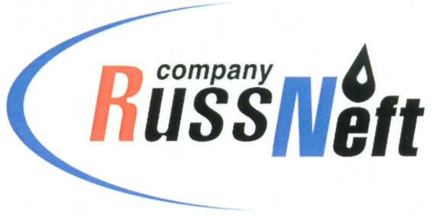
PJSC “RUSSNEFT” PRESS SERVICE

Tel.: (495) 411-63-24; (495) 411-63-21  Fax: (495) 411-63-19  E-mail: pr@russneft.ru  www.russneft.ru | 115054, Moscow,  Pyatnitskaya str., 69

PRESS RELEASE

November 18th, 2020

RussNeft’ subsidiary has met all commitments
under the agreement with Nizhnevartovsk
District administration

PJSC Varioganneft, a subsidiary of PJSC “RussNeft”, has fulfilled all its obligations within the socio-economic agreement framework with the administration of the Nizhnevartovsk District of the Khanty-Mansi Autonomous Okrug.
The subsidiary funded socially significant projects in the Nizhnevartovsk District, where the Company operates.
The socio-economic agreement between the district administration and Varioganneft, was first signed in 1995. Fulfilment of obligations under the agreements is one of the areas of RussNeft’s large-scale charity and sponsorship program, which is one of the priorities of the Company's social policy.

About Company:

PJSC “RussNeft” ranks among the top-10 largest oil companies by crude oil production in Russia.
The Company possesses a well-balanced portfolio of assets located in the key Russian oil and gas provinces (West Siberia, Volga-Urals and Central Siberia) as well as in Azerbaijan.
The headcount of the Company is around 10,000 employees.

PJSC “RussNeft” Press Service
Tel.: (495) 411-63-24, Fax: (495) 411-63-19
E-mail: pr@russneft.ru

