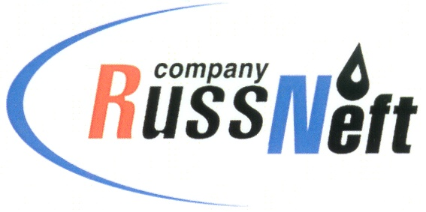
PJSC “RUSSNEFT” PRESS SERVICE

Tel.: (495) 411-63-24; (495) 411-63-21  Fax: (495) 411-63-19  E-mail: pr@russneft.ru  www.russneft.ru | 115054, Moscow,  Pyatnitskaya str., 69

PRESS RELEASE
May 15, 2026

RusAccreditation acknowledges the competence of the chemical analytical laboratory of RussNeft

The Ulyanovsk branch of PJSC “RussNeft” has completed a series of activities to certify the competence of its chemical analysis laboratory with the Federal Accreditation Service. RusAccreditation included the branch's laboratory as a test laboratory in the national accreditation system in 2021, allowing the Company to reduce operating costs for oil preparation and delivery.

For 5 years, RussNeft's branch has been using its own laboratory to conduct a detailed crude assay of oil supplied to the main oil pipeline system.

In April of this year, during an expert assessment commissioned by RusAccreditation, a check was conducted on the metrological support of measuring tools, testing and auxiliary equipment, and the existing quality assurance system for measurement results, confirming the laboratory's full compliance with the regulatory authority's requirements.

About the Company:
PJSC “RussNeft” ranks among the top-10 largest oil companies by crude oil production in Russia.
The Company possesses a well-balanced portfolio of assets located in the key Russian oil and gas provinces (West Siberia, Volga-Urals and Central Siberia).
The headcount of the Company is around 6,000 employees.

Press Service of PJSC "RussNeft"
Phone: (495) 411-63-24, Fax: (495) 411-63-19
E-mail: pr@russneft.ru

