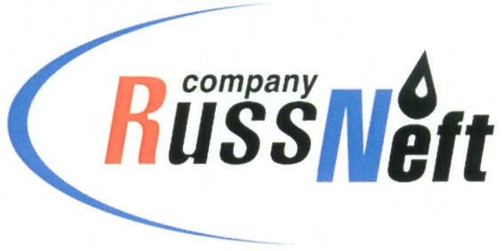

**PJSC “RUSSNEFT” PRESS SERVICE**

|  |  |
| --- | --- |
| **Tel.: (495) 411-63-24; (495) 411-63-21**  **Fax: (495) 411-63-19**  **E-mail: pr@russneft.ru**  [**www.russneft.ru**](http://www.russneft.ru/) | **115054, Moscow,**  **Pyatnitskaya str., 69** |

**PRESS - RELEASE**

**November 19, 2024**

**"RussNeft" provides support for dealing with pressing issues of indigenous peoples of the North**

PJSC RussNeft actively participates in addressing pressing issues of the indigenous peoples of the North, inhabiting the Company's license areas in the Khanty-Mansiysk Autonomous Okrug (Yugra).

In this connection, in response to the appeal of the indigenous inhabitants of Yugra, the Nizhnevartovsk branch of the Company assisted in the elimination of natural river jam on the territory of ancestral lands in the bed of the Entl-Gun-Yogan River. Technical measures involving heavy equipment, initiated by the Company, made it possible to restore the natural flow of the river and fishing, which provides a significant portion of the income for the indigenous people of Yugra.

In total, RussNeft has allocated more than 24 million rubles this year for compensation payments to indigenous residents of the region. The Company produces hydrocarbons within the Nizhnevartovsk, Surgut, Khanty-Mansiysk, Nefteyugansk and Oktyabrsky districts of Yugra on lands belonging to 17 territories of traditional nature management of 70 families of indigenous peoples of the North.

The company pursues a targeted policy aimed at preserving, supporting and developing the traditional way of life, original culture and customs of the indigenous population of Yugra.

**About the Company:**

PJSC “RussNeft” ranks among the top-10 largest oil companies by crude oil production in Russia.

The Company possesses a well-balanced portfolio of assets located in the key Russian oil and gas provinces (West Siberia, Volga-Urals and Central Siberia).

The headcount of the Company is around 7,000 employees.

**Press Service of PJSC "RussNeft"**

**Phone: (495) 411-63-24, Fax: (495) 411-63-19**

**E-mail:**[**pr@russneft.ru**](mailto:pr@russneft.ru)