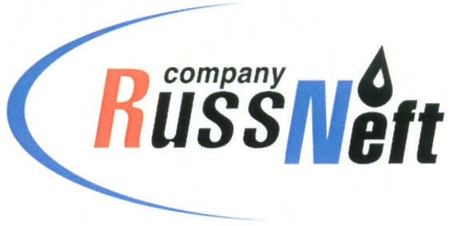

PJSC “RUSSNEFT” PRESS SERVICE

Tel.: (495) 411-63-24; (495) 411-63-21  Fax: (495) 411-63-19  E-mail: pr@russneft.ru  www.russneft.ru | 115054, Moscow,  Pyatnitskaya str., 69

PRESS RELEASE
March 28, 2022

Ulyanovsk branch of RussNeft continues to optimize production processes and costs

The Scientific and Technical Council of RussNeft selected 8 ideas of employees - innovators of the Ulyanovsk Branch to optimize production processes for implementation in 2022.
S.A. Shulga, the head of the ESP-equipped wells department, became the winner in the nomination "Maximum effect" in the Ulyanovsk branch. Authors of the ideas accepted for implementation will be rewarded with prizes.
In total, in 2021, the branches and subsidiaries of PJSC “RussNeft” developed 77 activities.

About the Company:
PJSC “RussNeft” ranks among the top-10 largest oil companies by crude oil production in Russia.
The Company possesses a well-balanced portfolio of assets located in the key Russian oil and gas provinces (West Siberia, Volga-Urals and Central Siberia) as well as in Azerbaijan.
The headcount of the Company is around 8,000 employees.

PJSC “RussNeft” Press Service
Tel.: (495) 411-63-24, Fax: (495) 411-63-19
E-mail: pr@russneft.ru

