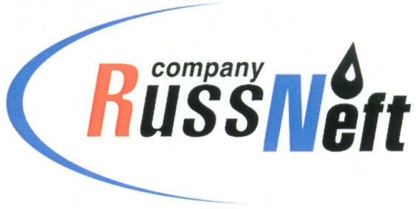
PJSC “RUSSNEFT”
PRESS SERVICE

Tel.: (495) 411-63-24; (495) 411-63-21  Fax: (495) 411-63-19  E-mail: pr@russneft.ru  www.russneft.ru | 115054, Moscow,  Pyatnitskaya str., 69

PRESS - RELEASE
May 6, 2021
«RussNeft» continues reforestation programme

PJSC «RussNeft» will triple the volume of reforestation work in 2021. This year the Company plans to plant about 2 million seedlings on the area of more than 540 hectares (ha) in Khanty-Mansi Autonomous District (Yugra).
Reforestation work last year affected an area of 170 hectares, where more than 634,000 seedlings were planted at the expense of RussNeft.
The Company uses improved and varietal forest plant seeds adapted to the regional characteristics of the planting area when replanting forests. Pine seedlings pre-grown in nurseries to a height of 12-20 cm are usually used for reforestation.
The reforestation programme is implemented in areas allotted by forestry units to compensate for cuttings at infrastructure construction sites for oil production and seismic surveys.
«RussNeft» pays close attention to compliance with environmental legislation and prevention of the negative impact of production activities on the environment.

About the Company:

PJSC “RussNeft” ranks among the top-10 largest oil companies by crude oil production in Russia.
The Company possesses a well-balanced portfolio of assets located in the key Russian oil and gas provinces (West Siberia, Volga-Urals and Central Siberia) as well as in Azerbaijan.
The headcount of the Company is around 9000 employees.

Press Service of PJSC "RussNeft"
Phone: (495) 411-63-24 Fax: (495) 411-63-19
E-mail: pr@russneft.ru

