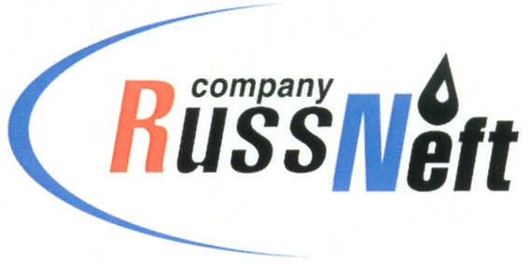

**PJSC “RUSSNEFT” PRESS SERVICE**

|  |  |
| --- | --- |
| **Tel.: (495) 411-63-24; (495) 411-63-21**  **Fax: (495) 411-63-19**  **E-mail: pr@russneft.ru**  [**www.russneft.ru**](http://www.russneft.ru/) | **115054, Moscow,**  **Pyatnitskaya str., 69** |

**PRESS - RELEASE**

**December 10, 2024**

**RussNeft held scientific and technical conferences of young specialists in its branches**

Scientific and technical conferences of young specialists were held in the branches of PJSC “RussNeft”. The best projects were nominated for participation in the corporate conference to be held next year.

In the Khanty-Mansiysk branch, work was presented at the conference in the following areas: electric power, IT, wells drilling, production equipment repair, oil and gas production processes upgrade. The project "Artificial Intelligence for optimizing information and communication technology costs", developed by Alexander Anokhin, the leading engineer of the branch, was recognized the winner.

The Ulyanovsk branch won the project "Possibilities of using a multiphase flowmeter", developed by geologist Arthur Kagramanov. The conference reviewed the works in the sections "Geology and Development", "Energy and energy conservation", "Oil production and treatment", "Drilling and well repair".

In the Saratov branch of the Company, the competition jury reviewed 12 projects, including one collective work. After summing up the results, the leading specialist of the branch Irina Volkova with the project "Acoustic resonance method of pipeline diagnostics" became the winner of the competition.

The competition commissions in the branches had the following criteria for the selection of works: the relevance and novelty of the project, the possibility of implementation, the quality and depth of the study of the issue, the economic feasibility of the proposed solution.

About the Company:

PJSC “RussNeft” ranks among the top-10 largest oil companies by crude oil production in Russia.

The Company possesses a well-balanced portfolio of assets located in the key Russian oil and gas provinces (West Siberia, Volga-Urals and Central Siberia).

The headcount of the Company is around 7,000 employees.

**Press Service of PJSC "RussNeft"**

**Phone: (495) 411-63-24, Fax: (495) 411-63-19**

**E-mail:**[**pr@russneft.ru**](mailto:pr@russneft.ru)