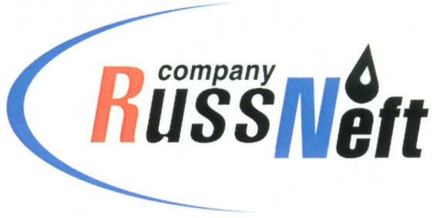
PJSC “RUSSNEFT” PRESS SERVICE

Tel.: (495) 411-63-24; (495) 411-63-21  Fax: (495) 411-63-19  E-mail: pr@russneft.ru  www.russneft.ru | 115054, Moscow,  Pyatnitskaya str., 69

PRESS - RELEASE
June 16, 2021
RussNeft has become one of the best in the field of environmental protection in Yugra

PJSC "RussNeft" was recognized as the winner of the competition "The best oil and gas production company in Yugra in the field of environmental protection" in 2020.
The company became the winner in Category II - companies with oil production from 1 million tons to 5 million tons per year.
The competition was held within the framework of the XVIII International Ecological Action "To Save and Preserve". When summarizing the results, the jury of representatives of federal and regional authorities proceeded from the following indicators: pipeline accidents, oil-contaminated lands area, wastes utilization and decontamination, as well as other equally important aspects of the activities.
About 600 thousand residents of the Autonomous District, Russia and foreign countries - Egypt, Italy, Germany, Estonia, Moldova, Belarus, Ukraine, Kazakhstan, Uzbekistan - took part in the international environmental action.

About the Company:
PJSC “RussNeft” ranks among the top-10 largest oil companies by crude oil production in Russia.
The Company possesses a well-balanced portfolio of assets located in the key Russian oil and gas provinces (West Siberia, Volga-Urals and Central Siberia) as well as in Azerbaijan.
RussNeft pays close attention to compliance with environmental law and prevention of the negative impact of production activities on the environment.
The headcount of the Company is around 9,000 employees.

Press Service of PJSC "RussNeft"
Phone: (495) 411-63-24, Fax: (495) 411-63-19
E-mail: pr@russneft.ru

